Task Manager

[intro]

$$A task manager manages the status of all taskes$$

$$and it fetch performance$$

$$such as CPU^{'}s performance, memory^{'}s performance etc.$$

[application]

$$\left(1\right)Kill and create a new task.$$

[issue]

[Ending file explorer = black screen and internet problems. - Microsoft Community](https://answers.microsoft.com/en-us/windows/forum/all/ending-file-explorer-black-screen-and-internet/b9fc6fd6-3697-4b0a-abb8-ac1191ec5401)

[Ended Process windows explorer and now screen is all black!! | Tech Support Forum](https://www.techsupportforum.com/threads/ended-process-windows-explorer-and-now-screen-is-all-black.639710/)



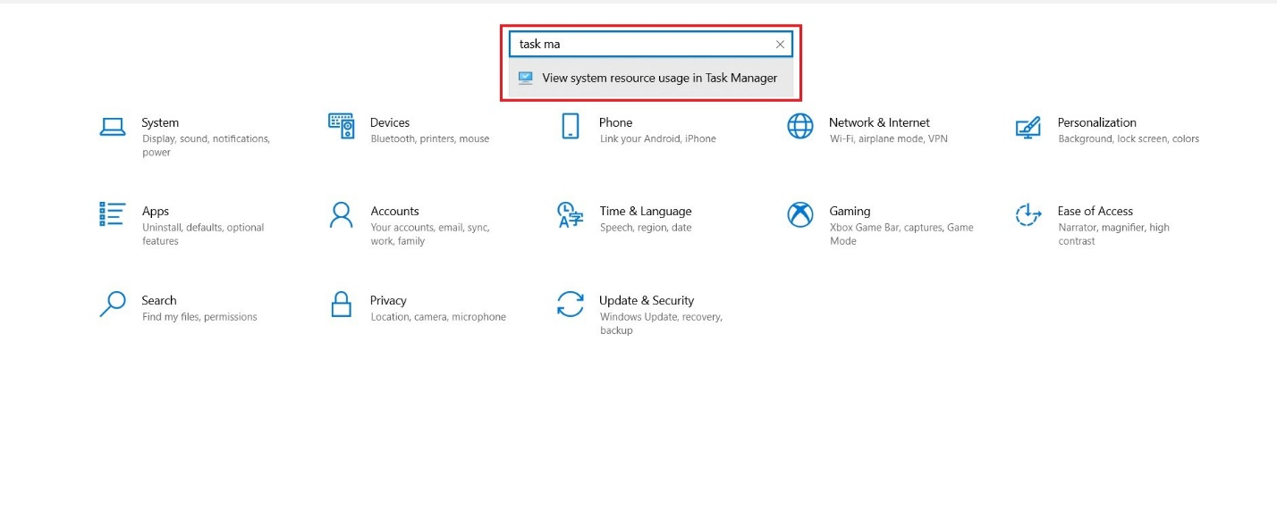

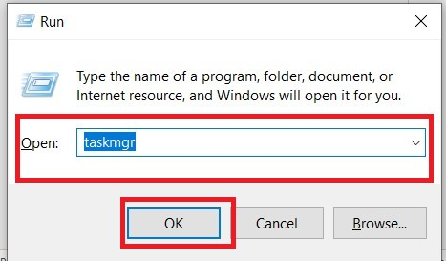

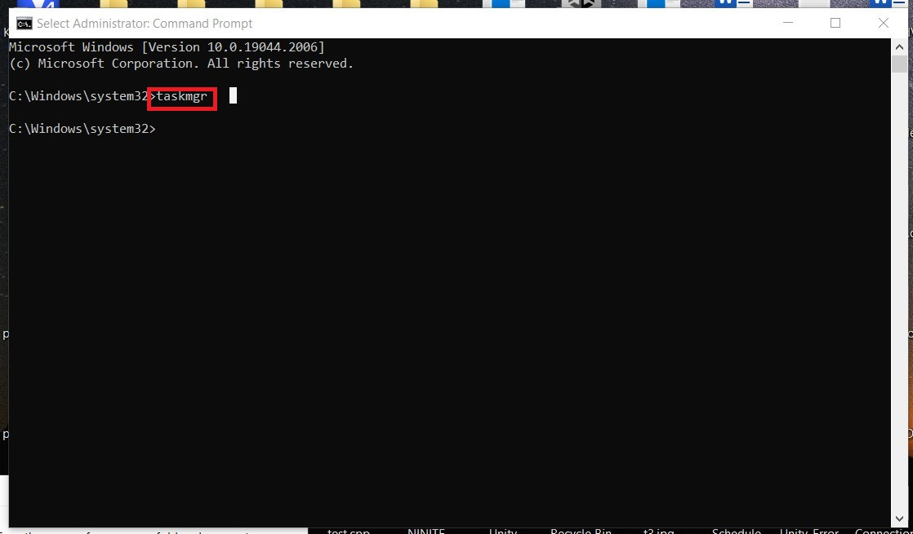

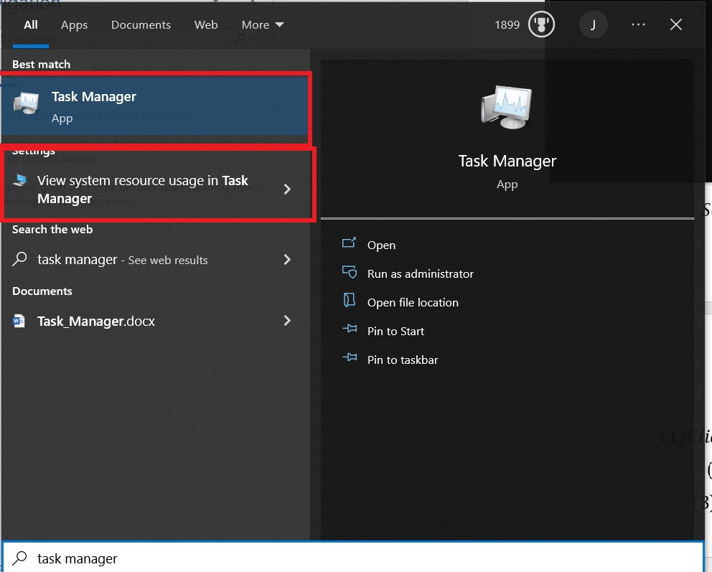

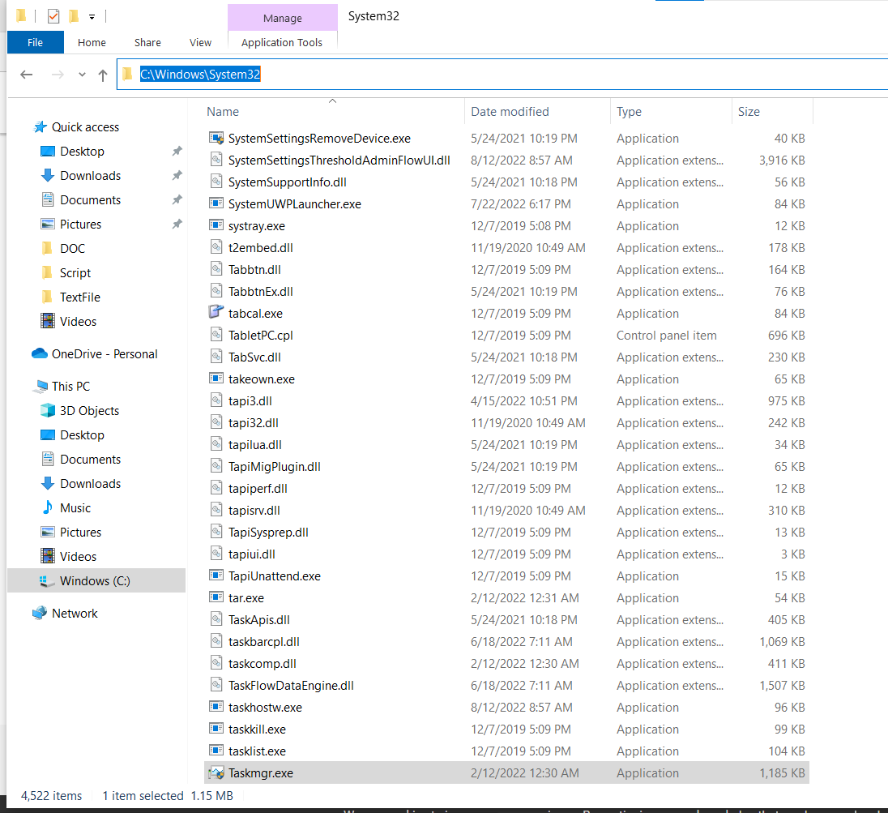

[ref]

[Task Manager (Windows) - Wikipedia](https://en.wikipedia.org/wiki/Task_Manager_(Windows))

[How to Open Task Manager on Windows 10? 10 Ways for You! (minitool.com)](https://www.minitool.com/news/how-to-open-task-manager.html)